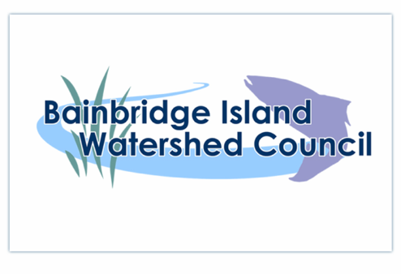
November 19, 2020, 7pm
IN THE YEAR OF COVID

Attending: Deb Rudnick (Chair), Bebe Rowlette, Stella Collier, John Williams, Diane Landry

BIWC Updates and programs:

- Salmon Monitoring update: We are starting to see returning spawners! So far reports in from Manzanita Creek and Springbrook Creek of a few returning adults. Hoping more rain will bring more fish.
  - Bright salmon: we’ve found dead a few “bright” coho salmon on Manzanita and Springbrook, meaning fish that are still in their marine coloration and haven’t yet turned darker spawning colors. This is the first time we’ve observed this in our streams, and it may or may not be an issue of concern. On east side streams, this condition is sometimes associated with what is known as pre-spawning mortality in association with first-flush stormwater runoff that sends toxins into the streams, and to which coho appear to be particularly sensitive (for example see https://your.kingcounty.gov/dnrp/library/water-and-land/science/seminars/October-2007/pre-spawn-mortality-of-coho-salmon-in-restored-urban-streams.pdf). We are directing monitors to check the spawning conditions of any bright salmon carcasses by opening up the fish and checking for eggs. We will be keeping an eye on this issue and reporting in to DFW and the City.

- Springbrook Creek Culvert update: I am thrilled to report that the City has put the failing Springbrook weir system on their Capital Improvements Project! This is a great first step for pursuing sources of funding to replace this system. BIWC has been involved in monitoring and repair of this weir system for several years and is extremely pleased to see the City take this step forward. For more information on this weir system and proposals for its replacement, see the Springbrook Creek Watershed Assessment.

- Bainbridge Tree Tour: Deb is working with Sustainable Bainbridge board member Christine Perkins, COBI’s arborist Nick Snyder, and the BI Historical Museum’s Dan Groff to create a self-guided tour of historic trees of Bainbridge, based off of the wonderful tours that Olaf Ribeiro did for many years with the history museum. We are thinking this will be a google map that users can access via QR codes that are placed adjacent to a number of trees throughout the downtown core and around the Island. Stay tuned!

- 2021 ABC Environmental Conference: Entitled “Stewarding our Forests under Climate Change,” this year the Association of Bainbridge Communities annual environmental conference was delayed due to Covid and is currently being reimagined as a 4-part virtual conference over the month of March. Planning participants include BIWC, Parks Foundation, Land Trust, IslandWood, and several others. Stay tuned for program announcements!

- Updates from Stella: We had an opportunity to talk to Stella, the city’s National Pollutant Discharge Elimination System’s coordinator, about some of the City’s stormwater efforts around the Island. Stella talked about the recent work to replace soil and replant in the Winslow Way Low Impact Development rain gardens and how materials removed from the rain gardens are specially treated at a decant facility before landfilling because of the presence of toxins like heavy metals that wash off the roadways - interesting! We also talked about efforts to improve stormwater runoff and drainage at the Miller Rd City Lot, adjacent to Congregation Kol Shalom.

- Updates from John: John is the editor of Salish Magazine, a wonderful on-line magazine that explores the connections in the natural world of the Salish Sea. He will have a new issue coming out soon on Cycles in Nature. Be sure to check it out!

Events and opportunities:
Tree Planting at Port Gamble Heritage Park: Kitsap Environmental Coalition and Kitsap County Community Forester, Arno Bergstrom, have organized a four part tree planting event at Port Gamble Forest Heritage Park. The 875 potted cedar and pine trees will be planted by small groups of five volunteers in the "Stumps " area of the the park. In order to control group size, and keep things safe for everyone, volunteer slots will need to be reserved in advance. Available dates include Dec. 5th, and Dec. 12th from 9am-12:00pm.
If you are interested, please contact Lisa Hurt of Kitsap Environmental Coalition at rainbowzen1@gmail.com or (206) 866-8111.

Western Washington University’s Toxicology and Society Series of Webinars: Deb attended the November webinar on Ocean Microplastics with Dr. Peter Ross of Ocean Wise. It was fantastic! Go here to view the recording.
Next opportunity: December 3
Talk: Contaminants of Concern for Human and Environmental Health
Speaker: Nancy Denslow, University of Florida, Center for Environmental and Human Toxicology & Department of Physiological Sciences
https://huxley.wwu.edu/toxicology-speaker-series

NEXT MEETING: THURSDAY, JANUARY 21, 2021! Zoom link will be sent.
Happy New Year, Watershed Residents! May this be a new year of better health, for people and our environment.

